ATTENTION

THE EDITORIAL BOARD WILL REJECT ANY ARTICLE THAT DOES NOT FOLLOW THE WRITING GUIDELINES SPECIFIED IN THIS TEMPLATE

The article template serves both as the space for writing the manuscript and as the guideline for authors. All content and formatting rules contained in this template must be strictly followed. Every visible formatting element in the template should be treated as a guideline, even when not explicitly explained. For example, if a paragraph is written with a 0.5 cm indentation, using Arial Narrow 10 regular, single spacing, and without additional spacing before or after the paragraph, then such formatting must be considered mandatory. Authors are not permitted to write using different content structures or formatting styles.
To ensure clarity, carefully read the following instructions before you begin writing your article.
- Write your article directly in this template; do not create a separate file.
- Read all instructions and examples thoroughly, then apply them accordingly. For instance, if the title in the template is written in Sentence case, Arial Narrow 12, bold, blue, and left-aligned, you must follow that exact format. Pay close attention to the rules and examples for writing the title, author names, affiliations, abstract, introduction, methods, results, discussion, and references.
- Be meticulous when writing authors’ names, as only you can ensure their accuracy. Abbreviating names is not allowed—for example, writing “N” instead of “Nugroho”—unless the author’s official name is indeed an abbreviation.
- Do not violate the rules for writing tables and figures. Carefully follow the formatting guidelines for table and figure titles, sentence structure, and avoid using bold text. For figure titles, it is prohibited to replace the word “Gambar” with other terms such as diagram, chart, flow, scheme, graph, and so on.
- Citations and references must follow the Vancouver style. In-text citations must be written using sequential numbers starting from 1, placed in square brackets, and positioned before the final period of the sentence. Examples:
… patient self-esteem [1].
… patient self-esteem [1, 2].
… patient self-esteem [1, 3, 7].
… patient self-esteem [1–3].
… patient self-esteem [1–3, 6, 8].
… patient self-esteem [1–3, 6, 8–11].
… patient self-esteem [1, 2, 5, 6, 9–12].
You must fully understand how to write references using the Vancouver style. Pay attention to the differences in formatting for various types of sources, such as journal articles, books, proceedings, websites, magazines, and others. When using citation software such as Mendeley, many potential errors can be avoided. Be cautious when writing references manually, as mistakes frequently occur in the use of punctuation marks (periods, colons, semicolons), spacing, and parentheses.

Jurnal Penelitian Kesehatan Suara Forikes (Journal of Health Research Forikes Voice)  DOI: http://dx.doi.org/10.33846/sf170101 | RESEARCH | p-ISSN 2086-3098 e-ISSN 2502-7778  Volume 17 Number 1, January 2026

The short title should reflect the main findings or conclusions and must be written in sentence case (Arial Narrow 14, bold, blue)

First Author¹, Second Author², Third Author³, Fourth Author¹
¹Department Name, University Name, City, Country; ²Department Name, University Name, City, Country; ³Department Name, University Name, City, Country
Correspondence: Second Author: Jl. Cemara 25, Sukorejo, Ponorogo, Indonesia; secondauthor@youremail.com

ABSTRACT (ARIAL NARROW 14, BOLD, BLUE)
Write the abstract in English, without indentation, in a single paragraph using Arial Narrow 10 font. The abstract should be written concisely. Citations are not allowed in the abstract. After the abstract, provide the keywords separated by semicolons (;). Keywords must be written in lowercase, except when this is not possible, such as for official abbreviations.
Keywords: first keyword; second keyword; third keyword

INTRODUCTION (ARIAL NARROW 14, BOLD, BLUE)
The introduction and subsequent sections must be written in Arial Narrow 10 font, with a 0.5 cm indentation and justified paragraph alignment. The introduction should include a background section containing the problem statement supported by justification and the state of the art, explaining the position of the current study in relation to previous relevant research. In addition to the background, the research objectives must also be stated. Citation writing must follow the Vancouver style, such as [1], or [1, 2, 6–9]. Copy your article into this template section by section or paragraph by paragraph to ensure that the template remains intact and that all embedded instructions remain identifiable.

METHODS (ARIAL NARROW 14, BOLD, BLUE)
For research articles, the methods section must include the type and/or design of the study, the time and location of the research, the population and sample, the variables, the data collection procedures for each variable, the data analysis methods, and ethical clearance. You may divide this section into several subsections if necessary. For other types of articles (literature reviews, book reviews, commentaries, opinions, scientific news, and letters to the editor), the structure should be adjusted according to the characteristics of each article type. Citation writing must follow the Vancouver style, such as [1], or [1, 3], or [1, 2, 6–9]. Copy your article into this template section by section or paragraph by paragraph to ensure that the template remains intact and that all embedded instructions remain identifiable.

RESULTS (ARIAL NARROW 14, BOLD, BLUE)
The results section may be divided into several subsections. For research articles, the results must be presented clearly and concisely. The following illustrates an example of subsection and sub–subsection formatting:

Title of the first level subsection (arial narrow 12, bold, blue)
Narrative text for first level subsection. Narrative text for first level subsection. Narrative text for first level subsection. Narrative text for first level subsection.

Title of the second level subsection (arial narrow 10, bold, blue)
Narrative text for second level subsection. Narrative text for second level subsection. Narrative text for second level subsection. Narrative text for second level subsection.

Title of the second level subsection (arial narrow 10, bold, blue)
Narrative text for second level subsection. Narrative text for second level subsection. Narrative text for second level subsection. Narrative text for second level subsection.

Choose the most effective method for presenting data, such as tables and figures. The requirements for table formatting are as follows:

Table 1. The table title begins with a capital letter, is placed above the table, left-aligned, and written in sentence case

Indicator | Code | Aspect | Expectation | Perception | Gap
Reliability | P1 | Use a closed-type table format as shown | 4.590909 | 2.772727 | -1.818182
Reliability | P2 | Each table cell entry must begin with a capital letter | 4.636364 | 2.909091 | -1.727273
Attention |  | Do not use bold text in either the table title or the table contents

When interpreting the contents of a table or diagram, avoid merely restating the information presented. Instead, focus on the conclusions that can be drawn, such as trends, majorities, patterns, directions, and other meaningful insights.
If you choose to present the results using figures (photographs, diagrams, charts, graphic images, etc.), follow the guidelines illustrated in the following example.

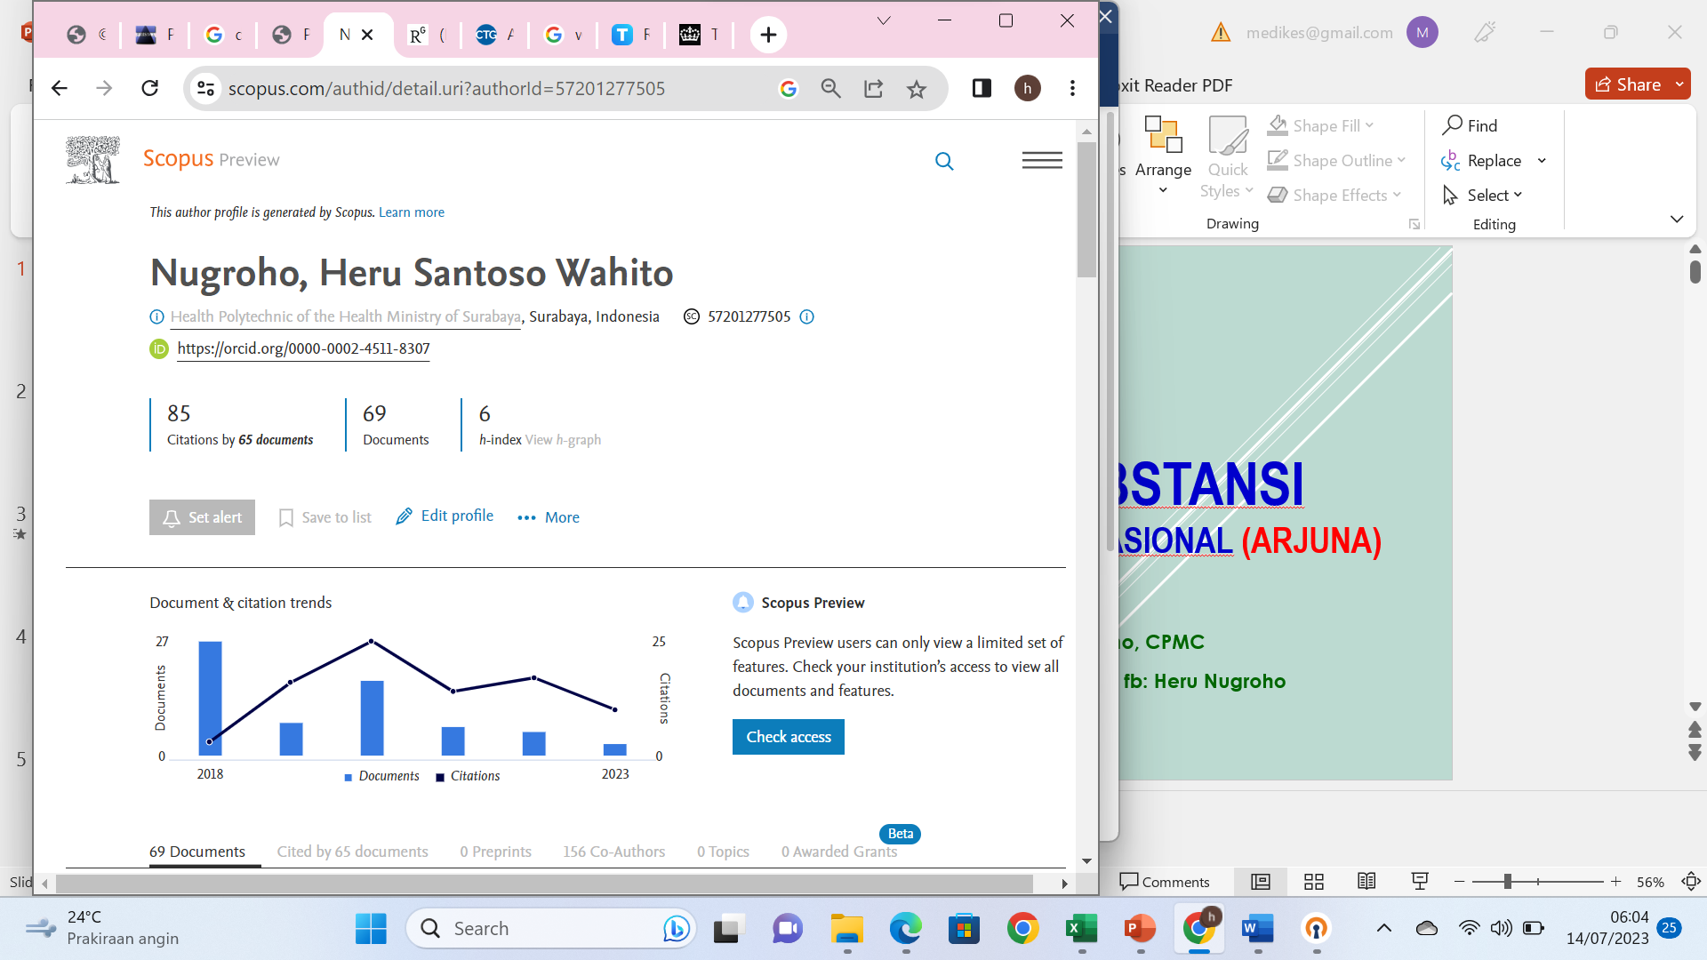

Figure 1. The figure title begins with a capital letter, is placed below the figure, left-aligned, and written in sentence case

DISCUSSION (ARIAL NARROW 14, BOLD, BLUE)
If necessary, the discussion section may also be written in several subsections. Ideally, the discussion must be presented in an integrated manner and should not be fragmented into unrelated parts. Numerical results from data analysis must not be repeated in this section; instead, present only the interpretations, such as: A is associated with B…, there is an effect of A on B…, A is proven effective for…, there are differences among A, B, and C…, the main determinants of A are…, and so forth.
Citation writing must follow the Vancouver style, such as [1], or [1, 3], or [1, 2, 6–9]. Copy your article into this template section by section or paragraph by paragraph to ensure that the template remains intact and that all embedded instructions remain identifiable.

CONCLUSION (ARIAL NARROW 14, BOLD, BLUE)
Write the conclusion in a comprehensive and integrative manner, without numbering, and in a qualitative form (avoid presenting numerical results from data analysis). You may also include suggestions or recommendations if deemed necessary.
After the conclusion, list the references using the Vancouver style. Remember: apply the Vancouver style correctly, not merely by numbering the entries. To minimize errors, it is strongly recommended that you use reference management software such as Mendeley, Zotero, EndNote, and others.
The smoothness of the publication process for your article greatly depends on your accuracy and adherence to the guidelines provided in this template.

Ethical consideration, competing interest and source of funding
-The ethical approval: This study had obtained ethical approval from the Health Research Ethics Commission of Poltekkes Kemenkes Surabaya, number: EA/2198/KEPK-Poltekkes_sby/II/2023.
-There is no conflict of interest related to this publication.
-Source of funding is authors.

REFERENCES (ARIAL NARROW 14, BOLD, BLUE)
- Sillehu S. Title of journal article. Journal Name. 2000;1(1):21–28. (journal)
- Nugroho HSW, Sillehu S. Title of magazine article. Magazine Name. 2018;21–18. (magazine)
- Nugroho HSW, Sillehu S. Title of proceeding article. In: Name E, editor. Title of Proceeding. City: Publisher Name; 2018. p. 23–29. (proceeding)
- Nugroho HSW. Title of web article [Internet]. Website Name. 2018 [cited 2018 Mar 15]. p. 1–17. Available from: http://articleurl (website)
- Nugroho HSW, Sillehu S, Mardiana N. Title of working paper. City; 2018. Report No.: 1. (working paper)
- Nugroho HSW, Baba A. Title of book. 1st ed. Editor Name, editor. City: Publisher Name; 2018. 1–101 p. (book)
- Institution Name. Title of book. 1st ed. Editor Name, editor. City: Publisher Name; 2018. 20–29 p. (institutional book)
- Nugroho HSW, Sillehu S. Title of chapter. In: Editor N, editor. Book Title. 1st ed. City: Publisher Name; 2018. p. 300–33. (book chapter)
- Nugroho HSW, Sillehu S, Suparji. Title of dissertation, thesis, undergraduate thesis, or report. University Name; 2018. (dissertation/thesis/undergraduate thesis/report)

